PARISH NEWS
The Deverills & Crockerton

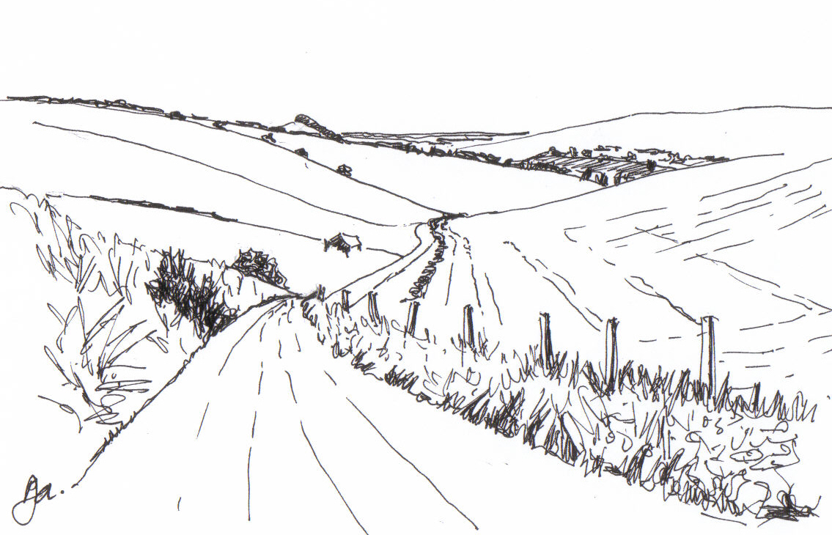

Pen Hill by Pat Armstrong

February 2008

Look inside for local information
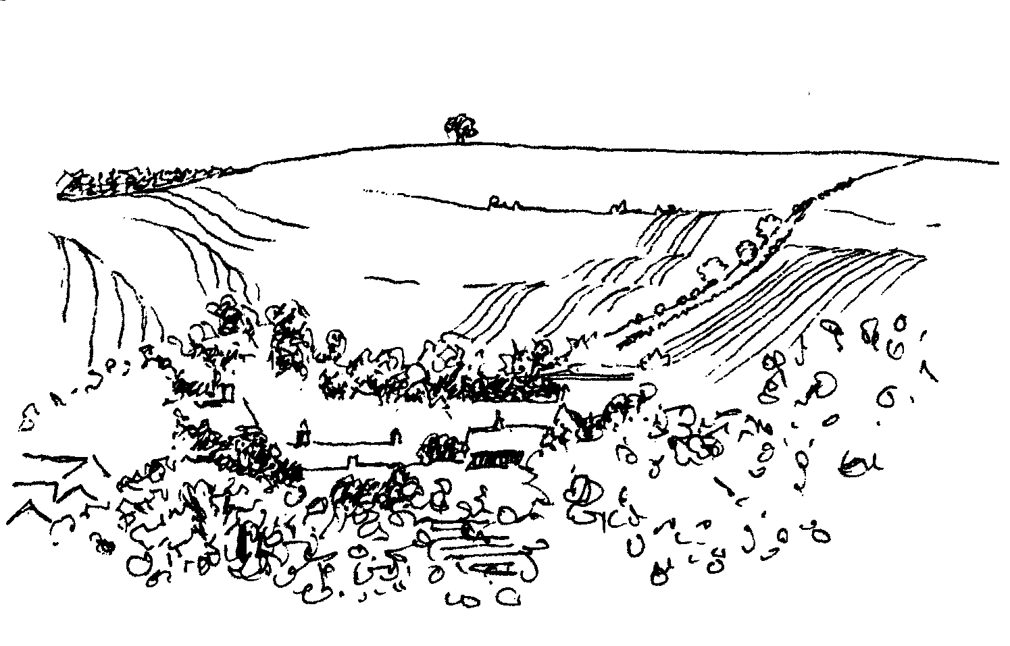

-2-

Longbridge Deverill Village Hall
Valentine evening
A romantic evening of music and poetry
Saturday 9th February 7.00 pm for 7.30 pm
A 2 course meal with glass of wine
Tickets £8 from Sylvia Titt 214825 or Pat Woods 840535

CROCKERTON MILLENNIUM COMMITTEE
Village Quiz Night
Sunday 10th February
At 7.30 pm in The Bath Arms Crockerton
Ticket £8.00 to include a main meal
To book please contact
Marion – 213739, Tracey – 216939, Bernie – 218401

UPPER DEVERILLS VILLAGE HALL

‘AN INCONVENIENT TRUTH’

The controversial environmental film
made by AL GORE

Friday 22nd February at 7.30 pm

Followed by a time of discussion

Bring your own drinks and glasses

-3-
LENT - a personal pilgrimage with Christ
Lent will soon be here! Shrove Tuesday and Ash Wednesday fall in the first week of February. Ash Wednesday is kept as a day of penitence and fasting, and services that day include a significant penitential element.
Lent is a time, I like to think of it as ‘a God-given time’, to take stock of where we are with God. Originally, Lent was the season of intense preparation for candidates for baptism at Easter. It has retained something of this as it is still seen as a time of growth in the faith and, therefore, in renewed commitment. It is good to make a realistic assessment of where we stand with God and to acknowledge our faults and failings. But it is not all doom and gloom. Remember the story of the prodigal son. Once he comes to his senses and realises his mistakes, he returns to his father and his family home. It is the compassion of the father not the son’s change of heart that is at the heart of the Gospel.
So I encourage you to use the days of Lent to take stock, to be honest with yourself and with God, and to be aware of the needs of others, especially those less fortunate than you are.
However you keep the days of Lent, consciously make it part of your personal pilgrimage. If a conversation with me would help, please make an appointment. Consider joining one of the Lent Study Groups in the Benefice, details are on page 9 of this Parish News.
May God bless your journeying towards Easter!
Norma Payne - The Rector

Annual Revision of the Church Electoral Roll
As in previous years the PCCs are required to conduct an annual revision of the Church Electoral Roll in the Spring. This revision must be completed in time for the Annual Parochial Church Meeting on Sunday 30th March. The period of the revision will be from 1st February until 15th March – a notice to this effect will be displayed on the notice board in each of our churches. Please will Parishioners let me know of anyone whose name they think should be removed from the Roll (with a reason please e.g. deceased, moved abroad, etc). As an aid there is a copy of the current Electoral Roll on the notice board of each church. Blank Electoral Roll registration forms will be placed at the back of each church for completion by anyone in the Parish whose name is not on the current Roll but who now wishes to be included. Please send the completed forms to me at Spring Cottage, Monkton Deverill, or hand them to a Church Warden. Could I also ask that you include on the forms, in addition, your telephone number and the name by which you wish to be known.
M M Tulloch Parish Electoral Roll Officer

-4-


Fairtrade Fortnight 2008

25th February to 9th March
Fairtrade has improved the lives of millions of people – farmers, agricultural and craft workers, and their families – in developing countries. During Fairtrade Fortnight each year, the Fairtrade Foundation, the body which awards the FAIRTRADE Mark, and local Fairtrade supporters all over the country make a special effort to promote Fairtrade to ensure that shoppers know that buying Fairtrade products makes a positive difference.
Warminster Fairtrade Group is busy planning events at which you will be able to sample, enjoy and buy Fairtrade products, and learn more about the producers and the Fairtrade market. You are warmly invited to join us. Please make a note of the dates and look out for more details in next month’s Parish News, the local press and on notice boards.
Saturday 1st March
Coffee Morning from 10.00 am - 12.00 noon at the Athenaeum
Thursday 6th March
Screening of the award-winning film Black Gold
Starting at 7.30 pm at Christ Church. Free admission – donations welcomed
Sunday 9th March
An Afternoon Tea Party from 3.00 pm - 5.00 pm at the Assembly Rooms
Saturday 8th March
Our Parish Fairtrade Event will be a ‘Chance to Chat over Coffee and Cake’
from 10.00 am - 12.00 noon in Longbridge Deverill Village Hall
Hope to see you there.
Helen Hemingway Local voluntary Traidcraft Representative
Member Warminster Fairtrade Group
Save the Children
A wonderful £2,030 was raised for the Save the Children at the popular Christmas Bazaar held at Mill Farm house, Hill Deverill in November 2007. A great result from a very happy event, where there were some lovely stalls. Thank you to all who contribute and support us and special thanks to Val Dale and her family.
The paper skip in Longbridge Deverill behind the closed Fish Farm is still going so please continue to bring your papers and magazines. The amount raised for Save the Children over the past 12 months was £1,293.24, slightly down on last year’s total so if you don’t already contribute to the collection please consider doing so. Newspapers, magazines and paperbacks are acceptable but no string, cardboard, plastic or yellow pages please. A big thank you to all who already contribute and support the collection.
Anne Hurd

-5-


Wiltshire Wildlife Trust - Collection of used Stamps

I would like to thank everyone for their tremendous effort in collecting used stamps to give to me for the Wiltshire Wildlife Trust. I will continue to collect them from you throughout the coming year, so please keep up the good work.
Also, I would like to thank you for the many gifts and good wishes I received during the Christmas period. May I wish you all a happy and prosperous new year.
David - the Postie
Longbridge Deverill Post Office Downgrading
This is an update on the situation and a reminder of the 31st January deadline of the consultation period. The Upper Deverills and Sutton Veny Parish Councils have written to object to the closure. Warminster Town and West Wiltshire District Councils are also objecting formally. At the invitation of Warminster's Mayor, the Chairman and Clerk of the Longbridge Deverill and Crockerton Parish Council met with the London representatives of the Post Office on 9th January and had a useful discussion. The Post Office representatives were unaware, particularly, of the access problems and of the closure of Purely Organics. The Chairman was assured that a Post Office presence would be maintained in Longbridge Deverill; the exact form of it now obviously required rethinking and the Post Office will be doing that. Formally, this is where the situation rests as at mid January. Change will definitely happen; we will always (until the next review!?) have a Post Office in Longbridge of some sort; all else is speculation until the Post Office comes back with a new ‘proposal'. The 31st January deadline will be very close by the time you read this. The person to write to is Tim Nickolls, Network Development Manager, National Consultation Team, FREEPOST CONSULTATION TEAM, or email: consultation@postoffice.co.uk. The Customer Helpline number is 08457 223344.
Michael Mounde
Longbridge Deverill & Crockerton Parish Council
The present Clerk is retiring shortly and the Parish Council is seeking a replacement Clerk. The Council meets every other month at 7.30 pm in the Longbridge Deverill Parish Hall. The Clerk is required to take minutes, carry out correspondence, make telephone calls, etc. The work is not onerous and the position is paid. Interested applicants, who must be computer literate, should contact the Chairman, Bill Hurd, on 840023 or the present Clerk, Michael Aplin, on 840684.

-6-
Classic New Orleans Jazz Evening
Friday 8th February
Warminster Rotary Club are organising a Classic New Orleans Jazz Evening on Friday 8th February at the Assembly Rooms, Warminster. The classic jazz will be played by the Avon Valley Jazz Band and a hot buffet is included in the ticket price of £12.50. The evening starts at 7.30 pm and a bar will be available. The money raised will go to the Rotary Foundation Charity and local charities, so come along for a great musical evening in aid of some worthy causes. Tickets are available from Nigel Poole on 840902 or email npoole@dsl.pipex.com. See you there.
Nigel Poole
Salisbury Theatre Club Trips

Monday 18th February ‘The Herbal Bed’ by Peter Whelan
Monday 17th March ‘People at Sea’ by J B Priestley

The cost is £15.00: theatre seat £10.00 and coach trip £5.00

Booking and payment in advance to Mary Stewart Cox Tel 840877
Longmead, Brixton Deverill, Warminster BA12 7EJ

Coach leaves Kingston Church 6.10 pm collects through the Deverills Performances begin at 7.30 pm

Salisbury Theatre Club
Unfortunately, due to many members succumbing to illness during the month of January, our numbers for the trip on Monday 21st January were too few to make the coach viable so sadly it had to be cancelled. However, we look forward to the next trips on Monday 18th February and Monday 17th March, as advertised above, and hope everyone will be feeling much healthier and ready for some excellent entertainment.
Mary Stewart Cox
Longbridge Deverill Village Hall
Valentine Evening Saturday 9th February 7.00 pm for 7.30 pm
Come along and join us for a great evening of romantic music and poetry with a delicious two course meal and a glass of wine. For tickets please contact Pat Wood 840535 or Sylvia Titt 214825. We look forward to seeing you.
-7-

Upper Deverills Village Hall
Eddie Mirzoeff’s Film Night - Friday 15th February at 7.30 pm
Following his previous film evenings Eddie Mirzoeff has kindly offered to show and describe two more films that he has produced. The first of these is the ‘The Front Garden’. A half-time snack will be provided for which a small donation will be requested but please bring your own drinks.

‘An Inconvenient Truth’ - Friday 22nd February at 7.30 pm
The environmental film made by Al Gore, which led to him being awarded the Nobel Peace Prize, will be shown. No bread and cheese this time, but please bring your own drink and glass. Much publicity and controversy has been generated by this film, and there will be a chance afterwards to discuss some of the issues raised in it which affect us all.
Spanish Evening - Saturday 19th April - a date for your diaries.
The committee has reviewed the 2008 programme of activities and decided to make some changes to the list of events that was published in the December Parish News:
Race Night - it has decided not to proceed with this event which was
originally scheduled for Saturday 8th March.
Christmas Bingo - it has also been decided not continue with this evening planned for Friday 5th December as support for this activity has been reducing in recent years but we shall keep it under review for future years.
The Committee are seeking to introduce more new activities and would welcome ideas and suggestions. In particular we are exploring the possibility of introducing speakers on any interesting or unusual topics. If you know of anyone whose specialist knowledge of a subject would make them a candidate please contact a committee member, see page 14.
Albert Lee for Upper Deverills Village Hall
Deverill Valley & Crockerton Women's Institute
Our monthly meeting will take place on Monday 11th February at 7.30 pm in Longbridge Deverill Village Hall, when Pauline and John Hilsdon will be showing slides of local villages. The competition is six Fairy Cakes. You are very welcome to come and join us at our meeting. For more information contact Ann Dufosee on 840360.

-8-
SERVICES PARISH OF DEVERILLS & HORNINGSHAM
Sunday Candlemas
3rd February Kingston - 8.00 am Holy Communion 1662
Canon Richard Askew
St Denys - 10.30 am Confirmation Service
Warminster

Horningsham - 5.00 pm Evensong
Rev Norma Payne
Ash Wednesday
6th February Longbridge - 10.15 am Ash Wednesday Service
Rev Norma Payne
Sunday Lent 1
10th February Kingston - 10.30 am Holy Communion
Rev Norma Payne
Horningsham - 11.15 am Holy Communion 1662
Rev John Goodden
Brixton - 6.00 pm Evening Prayer
Mr John Budgen
Sunday Lent 2
17th February Longbridge - 8.00 am Holy Communion 1662 Rev Norma Payne
Longbridge - 10.30 am Holy Communion
Rev Norma Payne
Sunday Lent 3
24th February Longbridge - 10.30 am Holy Communion
Rev Norma Payne
Horningsham - 11.15 am Morning Prayer
Col Robin Chappell
Sunday Lent 4
2nd March Kingston - 8.00 am Holy Communion 1662
Canon Richard Askew
Longbridge - 10.30 am Mothering Sunday Service
Rev Norma Payne
Horningsham - 3.00 pm Mothering Sunday Service
Rev Norma Payne

Tuesday, Wednesday, Thursday, Friday Longbridge 8.30 am Morning Prayer
Wednesday Longbridge 10.15 am Holy Communion

Brixton Church will be closed for redecoration from mid February and March

-9-

SERVICES PARISH OF CORSLEY & CHAPMANSLADE
Sunday Candlemas
3rd February Corsley - 9.00 am Holy Communion (said)
Rev Norma Payne
St Denys - 10.30 am Confirmation Service
Warminster

Chapmanslade - 4.00 pm Tea Service
Rev Di Britten
Ash Wednesday
6th February Chapmanslade - 6.30 pm Ash Wednesday Service
Rev Norma Payne
Sunday Lent 1
10th February Chapmanslade - 9.00 am Holy Communion
Rev Norma Payne
Temple - 11.00 am Morning Prayer
Col Robin Chappell
Sunday Lent 2
17th February Chapmanslade - 9.00 am Holy Communion Rev John Goodden
Corsley - 6.00 pm Evening Worship
Rev Norma Payne
Sunday Lent 3
24th February Temple - 9.00 am Holy Communion 1662
Rev Norma Payne
Corsley - 10.30 am Parish Service
Rev Di Britten

Lent Group - Bible Study based on Matthew’s Gospel
Venue: The Vicarage, Longbridge Deverill
Days: Tuesday 12th, 19th, 26th February
Tuesday 4th March and Thursday 13th March
Time: 7.30 - 9.00 pm

THE DEVERILLS REGISTER
Funeral at Longbridge Deverill
Barrie Clark Tuesday 15th January
Interment of Ashes Longbridge Deverill
Barrie Clark Tuesday 22nd January

-10-

Ivy House St Denys Retreat Centre
Thursday 21st February
Community Gathering Day
For more information please phone 214824

Church Cleaners for January
Kingston – Mrs Stratton & Mrs Mounde
Brixton – Mrs Greenwood & Mrs Marsh
Longbridge - Monday 4 February 9.30 - 10.30 am - all helpers

Church Flower Arrangers for January
Kingston Brixton Longbridge
3rd Feb Mrs Mounde Mrs McDonald Mrs Ward
10th Feb Lent no flowers
17th Feb Lent no flowers
24th Feb Lent no flowers

CONTACT THE EDITOR AND WEBSITE
Parish News Editor - Judy Munro 844385
Contributions for the Parish News through my letterbox or
by post to Whitepits Lodge, Kingston Deverill, Warminster,
BA12 7HD or by Email: judymunro@tiscali.co.uk Thank you
Please remember the deadline is the 15th of every month

Website: www.deverills.org.uk Email address:info@deverills.org.uk
Website manager : Kate Wilkinson 844998
Contents: Parish News with church services, Parish Register, Events, Local News plus pictures and other information
Contact the Clergy
Please contact Rev Norma Payne (841321) or another member of the Clergy (see back page) if anyone is housebound and would like communion or a visit at home; or if you know of anyone who is ill and needs our prayers; or you wish to discuss any church matter.
Contact the office Administrator by email: office@cleyhill-team.org.uk or by telephone 210149.
-11-

Concert at St Mary the Virgin, Kingston Deverill
Saturday 3rd May at 7.30 pm
Although this seems a while away please make a note in your diaries now for what will be a very enjoyable occasion. The programme will be made up of piano quartets: Piano Quartet in G minor by Mozart, Piano Quartet in A by Chausson and Piano Quartet in E flat by Dvorak. The players will be Magnus Johnston (violin), Polly Wiltshire (viola), Harriet Wiltshire (cello) and Martin Walker (piano). They have all played in the church: Polly, Hattie and Martin in a concert three years ago, and my nephew Magnus at most Christmas carol services! The concert is in aid of the Deverill Valley Churches Fabric Fund.
Julian Wiltshire
Deverills Cricket Club Nets Sessions
The Deverills Cricket Club will be warming up for the new season with some practice at the indoor nets, Warminster Cricket Club. All are welcome. We will meet between 6.00 pm - 7.00 pm on:
Sunday 6th April, Sunday 13th April, Sunday 20th April
Jamie Fagan 844123
Parish Guide - Where have you been?
The Sloop Inn, Bantham, Devon
This month’s ‘Where have you been?’ is another place in Devon. It is recommended by Mike and Barbara Beilby and their Labrador, Benson, from Kingston Deverill. The Sloop Inn at Bantham is a 14th century inn located in the South Hams on the south Devon coast with views of Burgh Island. The journey time from the Deverills is approximately two hours. They have stayed at the inn on more than one occasion but last visited it just after Christmas 2007. They recommend it because of its location – marvellous walks, only 5 minutes from the beach, 15 minutes from the coastal path. A quiet, lovely spot where dogs are welcome at no extra charge, as far as they are aware. Also in February and March the Sloop is offering a special deal. You can stay there for only £15 per person per night, provided you eat your evening meal in the inn. I suggest that you check out the website (www.sloopatbantham.co.uk) for more details. The only bugbear they have identified is that parking can be a bit limited at times. They also stress that this is a local pub and is used as such, it is not a hotel. We have had a fairly dismal Christmas and are thinking of booking two or three nights there in March so that the two of us and the dog can give ourselves a boost after our various afflictions.
Please keep the contributions rolling in to me, Trish Shuler by email at farthings.kd@btinternet.com or through my door at Farthings, Kingston Deverill. You may have spotted the place I recommended last month is situated just outside the Devon village of North Tawton, which is the setting used for ‘Jam and Jerusalem’.
Trish Shuler 844291

-12-

Upper Deverills Parish Council
Upper Deverills Parish Plan
Enclosed in Upper Deverills residents’ copies of this Parish News is a flyer about a proposed Parish Plan. Do please look at it and contact either of the following if you are interested in taking part:
Richard Munro 844385 or email richardmunro@tiscali.co.uk
Ranald Blue 841374 or email theblues@uk2.net

The Fouling of Land by Dogs Order 2007

Allowing your dog to foul is not an offence. Not clearing up after your dog is an offence. Please note that if your dog fouls on any road, footpath or land open to the public and you fail to remove it forthwith, you are liable to a fine of up to £1,000.

The Rainfall in this Parish in 2007
The rainfall totals for 2007 provide an interesting difference between the West to the East end of the Parish.
Manor Farm, Kingston Deverill recorded 47.55 inches of rain.
Manor Farm, Longbridge Deverill recorded 37.95 inches of rain.
I have collected the rainfall figures from a total of 5 different weather watching enthusiasts within or adjacent to the parish. The result shows an average 40.41 inches of rain fell during 2007. This is about 2 inches more than the long running annual average. The past year has proved to be the wettest year since 2002.
If anyone else in the parish wishes to submit rainfall figures to me, I will be most grateful. Remember to try and read your rain gauge at the same time every day, site the gauge away from buildings and trees. Above all, chose your site where children or others cannot tamper with the gauge.
At the moment, I am told that the Wessex Water reservoirs are full and hopefully the rain is soaking through the ground to recharge the aquifers. It is interesting to see water flow starting before Christmas in the winterbourne known as ‘The Cut’ at Chitterne, also the river Till at Shrewton has started to flow earlier than for many years.
It is worth keeping a watchful eye on the river Wylye as it flows through our Parish. The extraction of water from the aquifer at the Brixton Deverill Pumping Station makes great demands on our water, and reduces the level of water in the river. At the time of writing, 12th January, although the river appears to be flowing quite well, it is much lower than it used to be when compared to a few years ago after similar quantities of rain. The demand on our water becomes greater each year, to provide for the ever growing towns such as Gillingham and others further west.
John Robins

-13-

Nature Notes
The wind and the rain woke me early this morning. We seem to be having more than our fair share of such weather. I thought the saying was “February fill dyke” not January! The weather has a tremendous affect on wildlife, stating the obvious perhaps but it’s true. For example a day of heavy rain and high winds can make it impossible for a kestrel to hunt. A night of similar weather is disastrous for barn owls whose feathers are adapted for silent flight and are not waterproof.
Last Saturday (12th January) was a beautiful day and came after an awful wet Friday. We drove up to London to visit my brother and his partner, and the wildlife was certainly making the most of the sunshine. We lost count of the number of kestrels that we saw hunting and buzzards either sitting watching the world or soaring on the thermals. Just before joining the M3, the field on the right was covered in rabbits; usually they’re out grazing en masse, early morning or late evening. I can only assume that after the previous days rain, the burrows were rather waterlogged and they were catching up on lost eating time.
Driving back later that evening it began to rain, again! I was therefore surprised to see a barn owl hunting ‘on the top’ between Chitterne and Knook. We did see a couple of mice rush across the road along here so perhaps the mouse population was particularly active and too attractive to worry about a bit of precipitation. Just as we dropped down the bends towards Knook, a hare ran across a way in front of us and stopped on the opposite side of the road dazzled in the headlights. We made sure that it jumped up into the bank to safety as there was a car approaching. It is always worth remembering that quite a bit of wildlife can be active under darkness, and to keep your eyes open for any movement in the banks. I often drive in the middle of the road, when conditions allow, in order to give myself more chance of avoiding any animal that should try to cross.
With wildlife you never know what you will see when you leave the confines of your house. We took some papers to the Save the Children Fund paper bank last week and had an unexpected super close-up view of a kingfisher hunting by the watercress beds. I do hope that it is careful with the A350.
The Big Garden Bird Watch, organised by the RSPB, takes place on the 26/27th January; if you should receive your magazine by then, you could take part. All you have to do is to record the species of birds visiting your garden and the highest number of each type you see altogether at one time. You just need to record the birds for an hour over the week-end. There are more details on the RSPB website and nearer the time there will be reports on the week-end event on the television and in the papers. Happy bird watching.
PS I still collect used stamps for the Wiltshire Wildlife Trust. They can be left at Longbridge Post Office with Dilys, or popped through our letterbox here at Broomclose Farm. Thank you.
Jane Trollope

-14-

LOCAL COUNCILS, SOCIETIES, GROUPS etc.

Longbridge and Crockerton Parish Council
Bill Hurd 840023 (Chair) Tom Minter 216909
Michael Aplin 840684 (Clerk) Elaine Pidgeon 212878
Julian Algar 840816 Graham Read 840296
Karen Manfield 215526 Peter Whithey 840347
Brian Marshall 214789

Upper Deverills Parish Council
Lady Felicity Wheeler 844683 (Chair) Mike Beilby 844995
Jacqueline Smith 840238 (Clerk) Ranald Blue 841374
Richard Munro 844385 Patricia Shuler 844291

District Councillor
Shear Water Ward - Michael Mounde 844363
Longbridge Deverill Village Hall Committee
Jo Nelson 840784 (Chair)
Anne Honley 215956 (Secretary) Sylvia Titt 214825 (Caretaker)
Upper Deverills Village Hall
Richard Cousens 844970 (Chair)
Mandy Martyn 844320 (Secretary) John Lea 844325 (Hall bookings)
Crockerton Millennium Committee
Marion Thomas 213739 (Chair)
Pre-School Children and Parents ‘Thursday Group’
Barbara Beilby 844995 (Chair) Sylvia Titt 214825 (Leader)
Deverill Valley & Crockerton W I
Pat Wood 840535 (President) Jill Russell 840209 (Secretary)

Deverills Cricket Club
Peter Child 01963 34593

Wylye Valley Tennis Club
Colin Singer 213696
Wylye Valley Flower Club
Mrs Hazel Yate 215617 (President) Mrs S Scott 213689 (Programme Secretary)
Wiltshire Wildlife Trust
www.wiltshirewildlife.org
Elm Tree Court, Long Street, Devizes SN10 1NJ
Rural Community Beat Officer - Neighbourhood Watch
PC Phil Bridge 0845 408 7000

-15-

FORTHCOMING EVENTS

- Hearing Loss Lip-reading Wednesdays Margaret Head (213259)
- Scottish Dancing Monday Evenings Aline Fry (841054)
- Badminton Mondays & Fridays 3.00 - 5.00 pm Alison Rymell (844819)
- Pre-school & Parents Group Thursdays 10.00 - 11.30 am See p14
- Deanery Confirmation Service Sunday 3rd February See p8/9
- Classic New Orleans Jazz Evening Friday 8th February See p6
- Valentine Evening Saturday 9th February See p2/6
- Crockerton Village Quiz Night Sunday 10th February See p2
- Women’s Institute Meeting Monday 11th February See p7
- Wylye Valley Flower Club ‘Boxes’ Tuesday 12th February See p14
- Eddie Mirzoeff Film Night Friday 15th February See p7
- Salisbury Theatre Club Monday 18th February See p6
- Ivy House Community Day Thursday 21st February See p10
- ‘An Inconvenient Truth’ Film Friday 22nd February See p7
- Coffee Morning for Fairtrade Fortnight Saturday 1st March See p4
- ‘Black Gold’ film Thursday 6th March See p4
- ‘Chat over Coffee and Cake’ Saturday 8th March See p4
- Tea Party Sunday 9th March See p4
- Upper Deverills Parish Council Meeting 7.30pm Wednesday 12 March
- Salisbury Theatre Club Monday 17th March See p6
- Deverills Cricket Club Nets Sunday 6th April See p11
- Deverills Cricket Club Nets Sunday 13th April See p11
- Spanish Evening Saturday 19th April See p7
- Deverills Cricket Club Nets Sunday 20th April See p11
- Concert St Mary's Kingston Deverill Saturday 3rd May See p11

-16-

PARISH OF THE DEVERILLS
Churches
SS Peter & Paul the Apostles Longbridge Deverill
St Michael the Archangel Brixton Deverill
St Mary the Virgin Kingston Deverill
Rector
Rev Norma Payne, 6 Homefields, Longbridge Deverill 841321
Clergy
Rev Richard Yates, 212 Pottle Street, Horningsham 844374
Rev Diana Britten, 69 Lane End, Corsley 01373 832515
Readers
Mr John Budgen, Woodlands, Sutton End, Crockerton 218203
Col Robin Chappell, 7 Elm Hill, Warminster 212153
Churchwardens
Mrs Elisabeth Atkinson, 133 Foxholes, Crockerton 212129
Mr Nigel Poole, 7 Homefields, Longbridge Deverill 840902
Mrs Mary Stewart Cox, Longmead, Brixton Deverill 840877
Major Mike Tulloch, Spring Cottage, Monkton Deverill 844381
Lay Pastoral Assistant Co-ordinator
Rev Norma Payne, 6 Homefields, Longbridge Deverill 84l321
PCC Treasurer
Mr David Stratton, Manor Farm, Kingston Deverill 844549
PCC Secretary
Mrs Anne Honley, Dry Hill House, Crockerton 215956
Church Electoral Roll Officer
Major Mike Tulloch, Spring Cottage, Monkton Deverill 844381
Parish News Editor
Mrs Judy Munro, Whitepits Lodge, Kingston Deverill 844385
Organist
Mr John Budgen, Woodlands, Sutton End, Crockerton 218203
Tower Captain
Mr Stephen Young, 68 Highbury Park, Warminster 212796
Caretaker - Longbridge Church
Mrs Sylvia Titt, 7 Church Street, Longbridge Deverill 214825
Office Administrator (Mon-Fri 10.00 - 12.00)
Mr Dick Collins, 22 Church Street, Warminster 210149

